Yerevan Parking Study
Field Surveys — Findings Report
On-street parking occupancy, regulation and displacement across six survey areas
Step 9 of the interactive Parking Reform briefing • Prepared for municipal stakeholders

Executive summary
This report presents the findings of the field parking surveys carried out across 6 areas of Yerevan. Surveyors recorded the vehicles physically present on every marked parking length throughout the working day, building a true picture of how intensively each street is used — rather than relying on design capacity alone. In total the survey covers 208 on-street parking segments holding 2,930 marked spaces, plus 427 spaces across six off-street yards.
Three findings stand out:
- Streets fill to capacity only at peak. Across the surveyed network, occupancy averages just 43% of capacity over the full day but climbs to 93% at the peak hour (both capacity-weighted). 69% of zones exceed 85% occupancy at the peak and 116 individual zones spill over 100%. More than half the kerb sits empty most of the day — the spaces exist, they are just all wanted at the same time and place. The problem is the timing and management of demand, not a raw shortage of spaces.
- Demand is short-stay and peaky. Parking is heavily concentrated in time. The fleet is dominated by short visits (68% stay under two hours), with a clear demand peak in the late morning and again in the evening.
- Removed parking can be re-absorbed — with one local exception. The redesign removes 1,643 on-street spaces. At the peak hour this displaces 908 parked cars. Nearby surviving on-street capacity and off-street yards are more than sufficient to absorb this city-wide, but the balance is tight in a few locations and one area (Gai Avenue) falls short locally.
What was surveyed and how
Field teams observed each marked parking length at regular intervals through the day and logged the vehicles present (by plate). This produces an occupancy profile for every street segment — not an estimate, but a count of real cars on the ground. From these observations the study derives three complementary views, each selectable as a layer on the interactive map:
- Occupancy — average and peak occupancy as a share of the segment's marked capacity;
- Regulation — whether each segment is paid (blue) or free (white) parking, plus off-street yards;
- Displacement — which segments are retained or removed under the redesign, and where the displaced cars can go.
Capacity is the number of marked spaces on each segment; where a segment was unmarked, capacity is estimated at one bay per 7.5 m of kerb. Occupancy figures are full-day averages unless labelled “peak”, which is the single busiest hour. Displacement is assessed at the peak hour — the moment the system is under most pressure.
Finding 1 — How full are the streets?
Over the full working day the surveyed network sits at 43% of capacity, yet at the peak hour it runs at 93%. That gap is the central finding. If the city were simply short of spaces, the daily average would be high too. Instead, more than half the kerb sits empty most of the day — the spaces exist, they are just all wanted at the same time and in the same place. The two occupancy columns below make this concrete: an area can look comfortable on a daily average and still be turning drivers away at its busiest hour. The pattern also varies sharply by area — the city-centre areas of Kentron and Komitas run well over capacity at peak, while the outer areas keep real headroom. The table ranks the areas from most to least stressed at peak.
Area | Survey  segments | Marked  spaces | Avg occupancy  (full day) | Peak occupancy  (busiest hour) | Zones over  capacity
Kentron | 58 | 586 | 73% | 138% | 42
Gai Avenue | 10 | 132 | 73% | 123% | 7
Komitas | 53 | 450 | 50% | 123% | 34
Garegin Nzhdeh | 31 | 451 | 42% | 92% | 15
Shiraz & Hasratyan | 34 | 439 | 27% | 75% | 13
Malatia-Sebastia | 22 | 872 | 25% | 54% | 5
All areas | 208 | 2,930 | 43% | 93% | 116
Peak colour: green = within capacity (≤85%); amber = at capacity (86–100%); red = over capacity (>100%). Both columns are capacity-weighted over surveyed zones.
Finding 2 — Paid vs free parking
Within the surveyed dataset, 276 of the 2,930 marked on-street spaces are recorded as paid and the remaining 2,654 as free, with the recorded paid parking concentrated in Komitas.
This understates priced parking on the ground. The survey's regulation coding distinguishes only free and a single paid class and does not capture all paid (red) lines that exist on street — so the true extent of priced kerb is higher than the recorded figures, and the paid/free split should be treated as indicative rather than exact.
The reliable, network-level takeaway is broader: across the surveyed areas, kerb space is largely unpriced or under-priced relative to the peak demand documented in Finding 1. Pricing remains the principal lever available to manage that demand wherever streets run hot at the peak hour.
Finding 3 — Spaces retained and removed under the redesign
The redesign retains 1,287 on-street spaces and removes 1,643 — 44% of surveyed on-street capacity is kept. The retain/remove decision is made street by street in the engineering workbooks, so the share kept differs greatly between areas: Komitas keeps three-quarters of its spaces, while Gai Avenue and Shiraz & Hasratyan are removed almost in full to make way for the corridor redesign.
Area | Spaces retained | Spaces removed | % retained
Kentron | 276 | 310 | 47%
Gai Avenue | 0 | 132 | 0%
Komitas | 342 | 108 | 76%
Garegin Nzhdeh | 165 | 286 | 37%
Shiraz & Hasratyan | 0 | 439 | 0%
Malatia-Sebastia | 504 | 368 | 58%
All areas | 1,287 | 1,643 | 44%
Finding 4 — Where do the displaced cars go?
Removing 1,643 spaces does not remove 1,643 cars: many of those spaces are empty for much of the day. At the single busiest hour, the removed segments hold 908 parked cars — this is the demand that must be re-accommodated. Against it, the study counts the spare capacity within walking distance: surviving (retained) on-street spaces, other nearby un-surveyed on-street parking, and off-street yards.
City-wide there is ample room: roughly 1,935 nearby off-street spaces and 391 additional on-street spaces are available, a surplus of about 1,418 spaces over peak displaced demand. The constraint is local, not global — the table below shows that every area can absorb its own displaced demand except Gai Avenue, where on-street and yard capacity together cover an estimated 89% of the peak displaced cars.
Area | Peak cars  displaced | Nearby  on-street | Nearby  off-street | % of demand  absorbed
Kentron | 250 | 34 | 395 | 100%
Gai Avenue | 131 | 89 | 27 | 89%
Komitas | 93 | 0 | 482 | 100%
Garegin Nzhdeh | 150 | 45 | 451 | 100%
Shiraz & Hasratyan | 185 | 127 | 387 | 100%
Malatia-Sebastia | 99 | 96 | 193 | 100%
All areas | 908 | 391 | 1935 | 100%
“% of demand absorbed” is capped at 100% where capacity meets or exceeds peak displaced demand. It reflects gross best-case capacity (every nearby space assumed available) and assumes drivers are willing to shift to off-street yards — so the Gai Avenue shortfall is a floor, and real-world friction (walking distance, willingness to pay) would tighten the balance elsewhere.

Displacement in detail — area by area
The panels below are taken directly from the interactive dashboard with the Displacement lens active. The stat block on the left of each panel reports, for that view, the peak cars displaced, the spaces removed, the nearby on-street and off-street capacity available to absorb them, and the share of displaced demand that capacity covers. On the map:
- green = surviving surveyed parking that the redesign keeps (it absorbs no displaced demand of its own — it is shown for context);
- yellow = nearby un-surveyed on-street parking within walking distance that can take displaced cars;
- purple = off-street yards available to absorb displaced demand.
Each subchapter pairs the dashboard view with a short reading of that area's displacement balance. Figures are peak-hour and reflect gross best-case capacity, as set out in Finding 4.
All areas
[missing image: All Areas Displacement.png]
Displacement lens — All areas (interactive dashboard).
Across the whole study, the redesign removes 1,643 marked spaces, but those streets hold only 908 parked cars at the single busiest hour — the real demand to be re-accommodated. Against it stand 391 nearby on-street spaces and 1,935 off-street spaces, a combined surplus of roughly 1,418 over peak demand. Surviving on-street parking alone covers 43% of the displaced cars; off-street yards close the remaining gap to full absorption. The headline is reassuring city-wide — there is enough room in principle — but it leans heavily on off-street capacity, which only works if drivers are willing to use it.
Kentron
[missing image: Kentron Displacement.png]
Displacement lens — Kentron (interactive dashboard).
Kentron is the tightest on-street case. The redesign removes 310 spaces and displaces 250 peak-hour cars, yet only 34 nearby on-street spaces remain to take them — barely 14% of demand. This is exactly what the 138% peak occupancy predicted: the centre has essentially no spare kerb. Absorption only reaches 100% because 395 off-street yard spaces carry almost the entire load. In practice, Kentron's displaced parkers must move off-street — there is nowhere on-street for them to go — so the off-street provision here is not a convenience but a prerequisite.
Komitas
[missing image: Komitas Displacement.png]
Displacement lens — Komitas (interactive dashboard).
Komitas removes the least (108 spaces) because the redesign retains roughly three-quarters of its parking — the large green surviving network on the map. The 93 displaced peak-hour cars find no spare on-street capacity (0), but the area's 482 off-street spaces absorb them comfortably, taking absorption to 100%. Displacement here is a small, well-covered problem.
Gai Avenue
[missing image: Gai Displacement.png]
Displacement lens — Gai Avenue (interactive dashboard).
Gai Avenue is the one area that cannot fully re-absorb its displaced demand. It is removed in full, and because it runs chronically over capacity almost every removed space is occupied at peak — 131 cars displaced against 132 removed. Only 89 nearby on-street and 27 off-street spaces are available, covering about 89% of demand and leaving a peak-hour shortfall of roughly 15 cars. This is the area that needs a targeted response — additional off-street provision or a phased removal — rather than relying on nearby capacity that is not there.
Garegin Nzhdeh
[missing image: Garegin Displacement.png]
Displacement lens — Garegin Nzhdeh (interactive dashboard).
Garegin Nzhdeh is removed almost in full, displacing 150 peak-hour cars. Nearby on-street parking is thin (45 spaces, 30% of demand), so absorption to 100% depends on the 451 off-street spaces around the area. The balance holds, but as in Kentron the off-street yard is doing the heavy lifting.
Shiraz & Hasratyan
[missing image: Shiraz & Hasratyan Displacement.png]
Displacement lens — Shiraz & Hasratyan (interactive dashboard).
Shiraz & Hasratyan has the healthiest balance among the fully-removed areas. Of its 185 displaced peak-hour cars, nearby on-street parking can take 127 (69%) on its own, with 387 off-street spaces covering the rest to reach 100%. Most displaced parkers can stay on-street nearby — the redesign is comfortably accommodated.
Malatia-Sebastia
[missing image: Malatia-Sebastia Displacement.png]
Displacement lens — Malatia-Sebastia (interactive dashboard).
Malatia-Sebastia is the easiest case. It displaces 99 peak-hour cars, and 96 nearby on-street spaces alone absorb 97% of them — almost the entire demand — before the 193 off-street spaces are even counted. With the area only about half-full at peak to begin with, the displacement balance is well within capacity at 100%.
Finding 5 — Who parks, and when
The surveyed fleet is overwhelmingly short-stay: 68% of vehicles park for under two hours (visitors), 30% for two to eight hours (commuters), and only 2% stay longer than eight hours. The average stay is 1.8 hours. This profile is favourable for pricing: short-stay demand is the most responsive to even modest parking charges, so priced kerb space would turn over faster and serve more users.
Demand builds through the morning to a late-morning peak (around 10:00, about 1,431 cars present network-wide) and holds high into the evening, confirming that the busiest streets are under sustained pressure across the working day rather than in a single rush hour.

Area profiles
Kentron
The congested city centre: well over capacity at peak and almost entirely free (unpriced) on-street parking. Pricing here would have the greatest effect.
Survey segments: 58 • marked spaces: 586 (paid: 0) • off-street yard: 60 spaces (NalbandyanYard001).
Occupancy: 73% average / 138% at peak • zones over capacity: 42.
Retained: 276 spaces (47%) • removed: 310.
Stay mix: 60% visitor / 37% commuter / 3% long (avg 2.2 h).
Gai Avenue
Gai Avenue / Mega Mall. Removed in full; the only area where nearby capacity does not fully absorb peak displaced demand — a local shortfall to address.
Survey segments: 10 • marked spaces: 132 (paid: 0) • off-street yard: 32 spaces (Palace Yard).
Occupancy: 73% average / 123% at peak • zones over capacity: 7.
Retained: 0 spaces (0%) • removed: 132.
Stay mix: 70% visitor / 25% commuter / 4% long (avg 2 h).
Komitas
The only substantially priced area (276 blue spaces) and the one that retains most of its parking (76%). Still over capacity at peak.
Survey segments: 53 • marked spaces: 450 (paid: 276) • off-street yard: 123 spaces (KomitasCity Yard).
Occupancy: 50% average / 123% at peak • zones over capacity: 34.
Retained: 342 spaces (76%) • removed: 108.
Stay mix: 67% visitor / 32% commuter / 1% long (avg 1.8 h).
Garegin Nzhdeh
Garegin Nzhdeh: high peak occupancy and a near-total removal; displaced demand is absorbed mainly by the off-street yard.
Survey segments: 31 • marked spaces: 451 (paid: 0) • off-street yard: 40 spaces (GNOFF Yard).
Occupancy: 42% average / 92% at peak • zones over capacity: 15.
Retained: 165 spaces (37%) • removed: 286.
Stay mix: 71% visitor / 28% commuter / 1% long (avg 1.7 h).
Shiraz & Hasratyan
Shiraz & Hasratyan: moderate occupancy, removed in full; comfortably absorbed by surrounding on-street and yard capacity.
Survey segments: 34 • marked spaces: 439 (paid: 0) • off-street yard: 71 spaces (ShirazYard010 Yard).
Occupancy: 27% average / 75% at peak • zones over capacity: 13.
Retained: 0 spaces (0%) • removed: 439.
Stay mix: 77% visitor / 22% commuter / 1% long (avg 1.6 h).
Malatia-Sebastia
Malatia-Sebastia: the most relaxed area, around half-full at peak, with the highest retention of its on-street parking and an easy displacement balance.
Survey segments: 22 • marked spaces: 872 (paid: 0) • off-street yard: 101 spaces (SebastiaYard006).
Occupancy: 25% average / 54% at peak • zones over capacity: 5.
Retained: 504 spaces (58%) • removed: 368.
Stay mix: 72% visitor / 28% commuter / 0% long (avg 1.6 h).

Visual analysis of the field-survey data
This section distils the field-survey dataset into a series of charts. Each is followed by a short note on what it implies for action, rather than a description of the chart itself.
Demand through the day
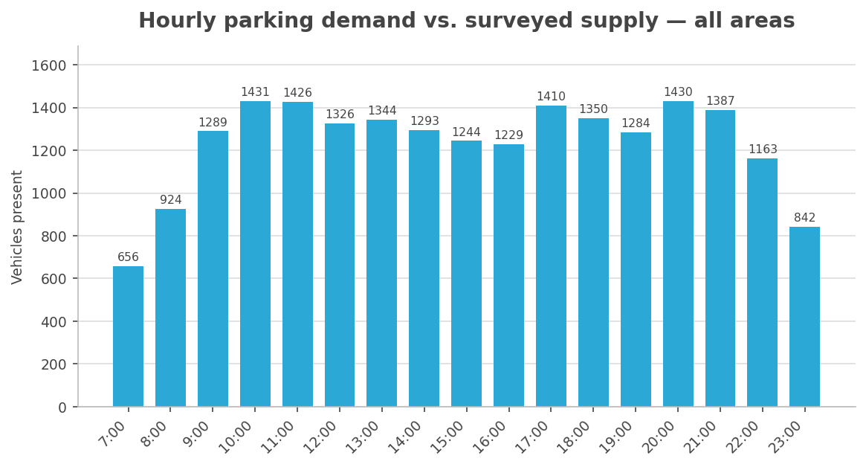
Hourly vehicles present across all surveyed areas, against surveyed on-street supply.
What now — the kerb is pressed twice a day — a late-morning and an evening peak — not in a single rush hour. Time-of-day pricing and any loading-bay time windows should target both peaks; the deep midday and overnight troughs are when relocated or shared parking can be steered without friction.
The gap between average and peak
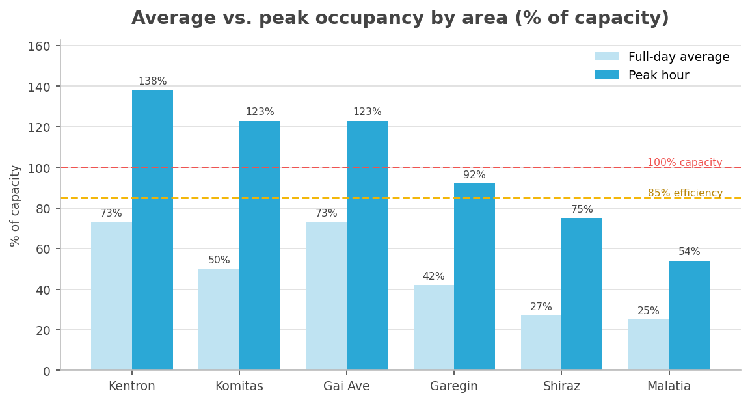
Capacity-weighted occupancy, full-day average vs. busiest hour, by area.
What now — manage the peak, not the average. The bars that clear the red line (Kentron, Komitas, Gai Avenue) are where pricing and turnover measures earn their place; the low-average outer areas have headroom to take reallocated demand today.
Who is parking
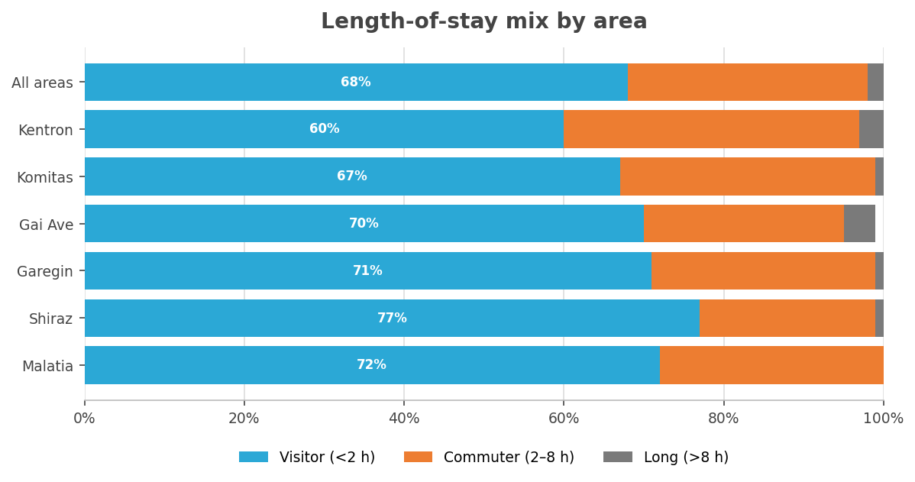
Share of vehicles by length of stay, by area.
What now — a short-stay kerb responds to hourly pricing and a two-hour cap far faster than to permits. Lead with turnover tools city-wide and reserve resident permits for the genuinely residential exceptions rather than applying them as a default.
Scale of the change
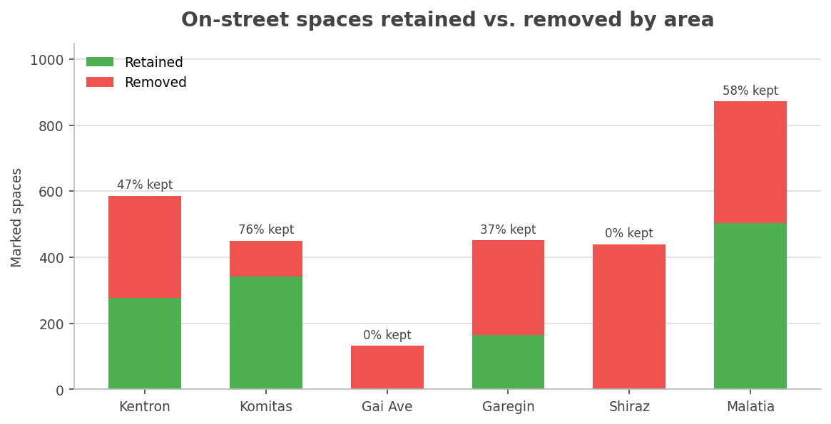
On-street spaces retained vs. removed under the redesign, by area.
What now — the areas removed in full (Gai Avenue, Shiraz) need their mitigation committed before construction starts; high-retention Komitas can be phased more gently. Sequencing should follow this chart, not a uniform timetable.
Can the displaced cars be re-parked?
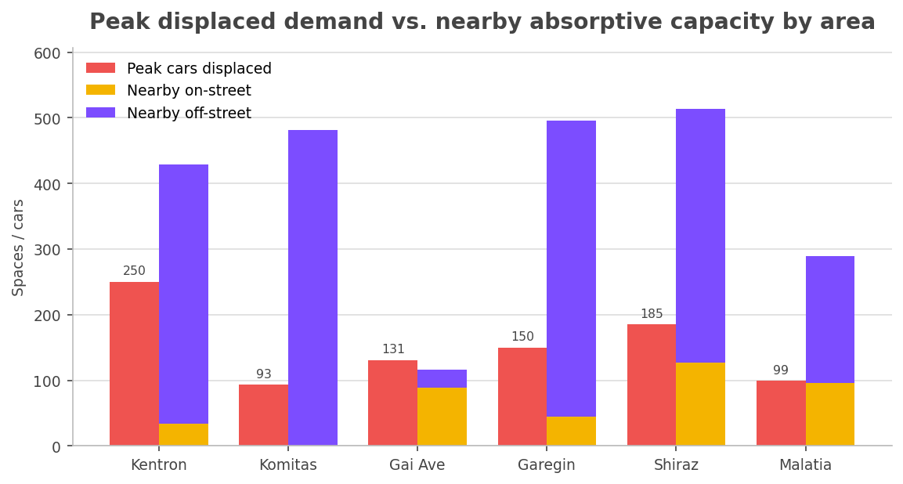
Peak displaced demand against nearby on-street and off-street capacity, by area.
What now — only Gai Avenue's red bar overtops its available capacity — commit a specific off-street or park-and-ride provision there before any removal. Everywhere else the balance holds only if the off-street yards are real, open and signed, so confirm them on the ground.
Where on-street will not catch the overflow
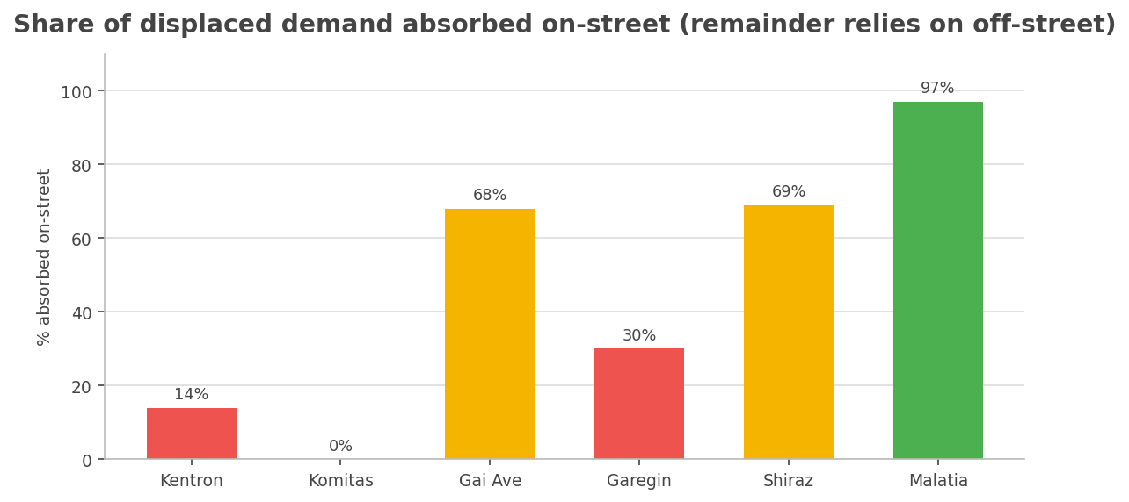
Share of each area's displaced demand that nearby on-street parking can absorb.
What now — in the core (Kentron, Komitas) on-street simply cannot absorb the displaced cars — secure off-street capacity there through courtyards, yards and park-and-ride. Save the side-street conversion lever for Malatia and Shiraz, where the chart shows it actually works.
How long the pressure lasts
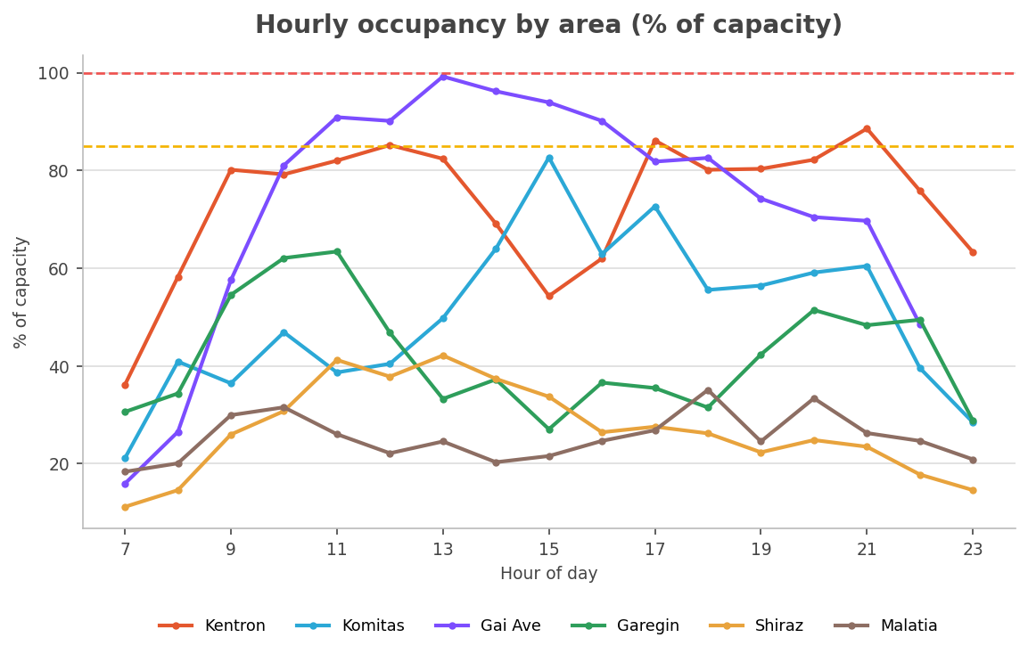
Occupancy as a share of capacity, hour by hour, for each area.
What now — the central areas sit at or above capacity for most of the working day, not for a single hour — so their pricing and enforcement need to run all day, while the outer areas only need attention in the peak windows.
The city-wide balance in one line
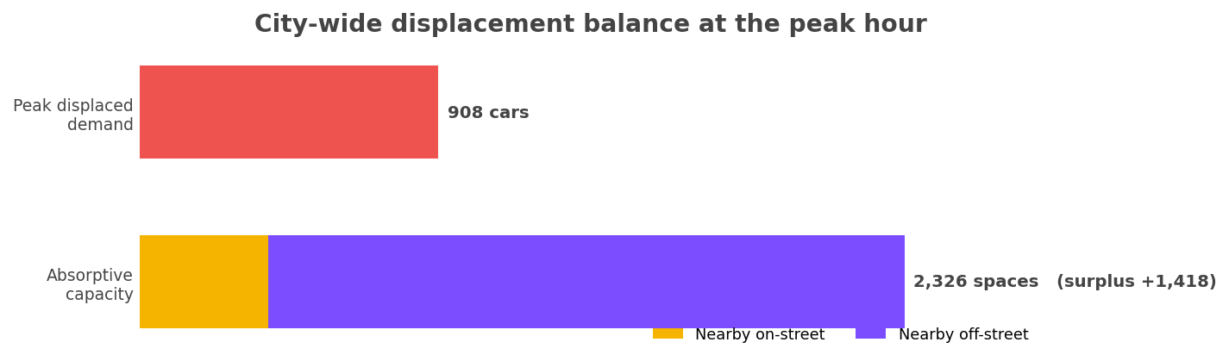
Peak displaced demand against total nearby absorptive capacity, all areas combined.
What now — the surplus is comfortable on paper, but it is overwhelmingly off-street. The task is to make that off-street capacity genuinely usable — open, priced and signed — not to find more land.
Who has a deficit
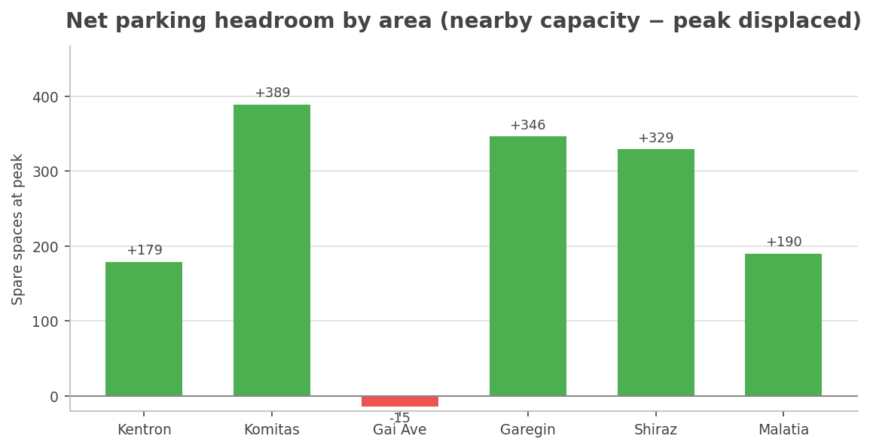
Spare spaces at the peak hour after absorbing displaced demand, by area.
What now — every area clears its own demand except Gai Avenue, whose bar falls below zero. That single deficit is the one place a do-nothing approach fails, so it warrants a dedicated provision rather than reliance on the surrounding network.
How hard the kerb works
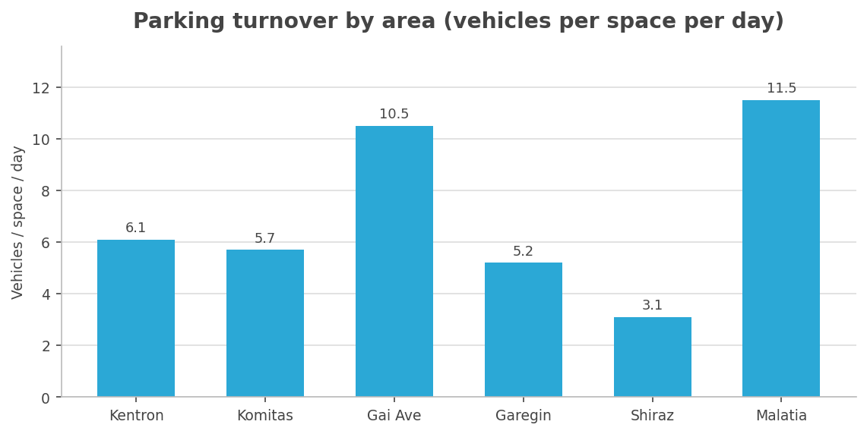
Vehicles served per marked space per day, by area.
What now — turnover is high across every area, confirming a short-stay, price-sensitive kerb. Hourly pricing and short maximum-stay limits will change behaviour quickly here — faster than permit-based schemes, which suit residential storage rather than this churn.
How widespread the stress is
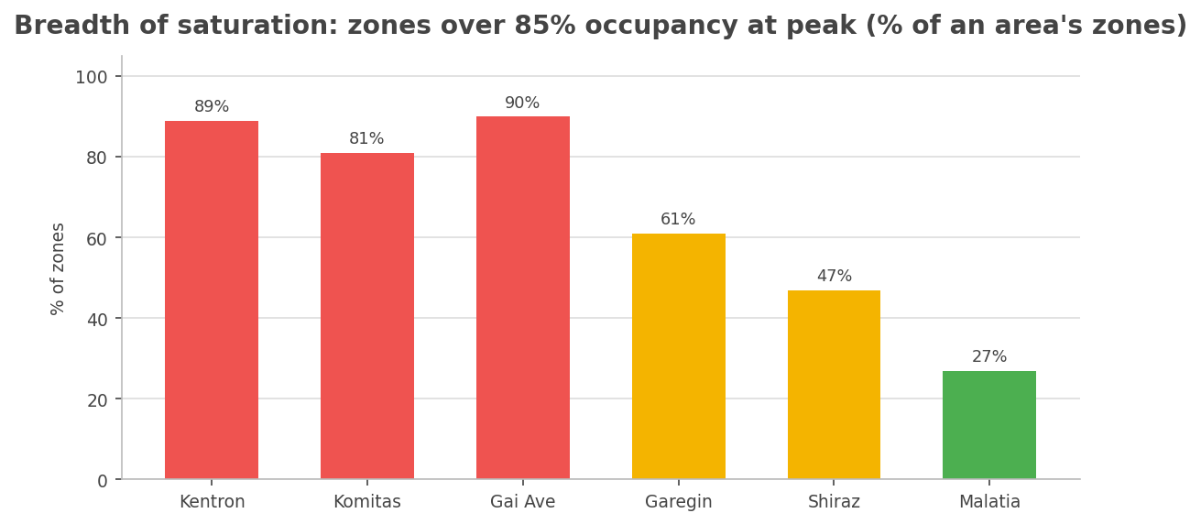
Share of each area's zones running over 85% occupancy at the peak hour.
What now — saturation is broad, not a handful of hotspots: in Kentron, Komitas and Gai Avenue most zones breach the 85% threshold. Mitigation in those areas should be applied zone-wide, not patched street by street.
Where to start
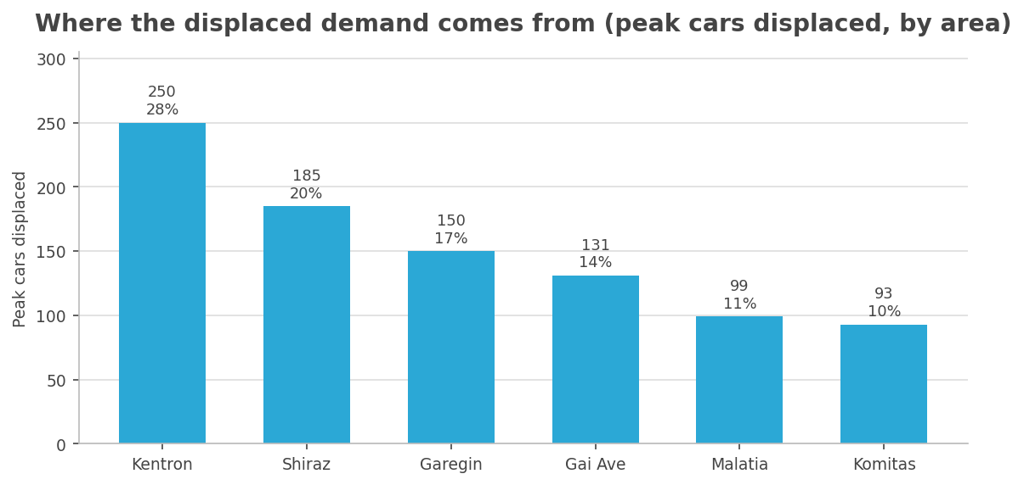
Peak cars displaced by area, ranked — the share of the city-wide total each contributes.
What now — Kentron alone accounts for over a quarter of all displaced demand, with Shiraz and Garegin next. Sequence mitigation effort and budget to the largest contributors first rather than spreading them evenly.
How many streets are over the line
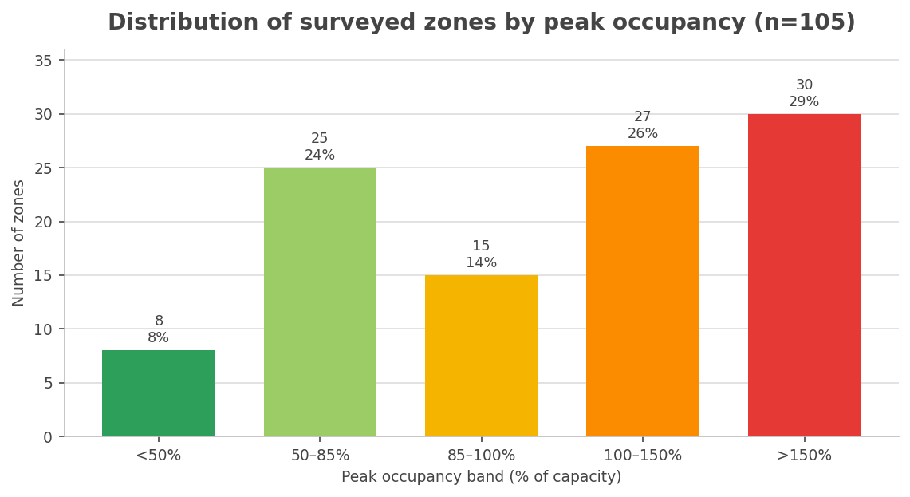
Every surveyed zone placed in a peak-occupancy band.
What now — more than half of all surveyed zones are over capacity at the peak, and nearly a third are above 150%. This is over-saturation at scale, not a few outliers — the over-100% tail is where pricing and enforcement have to land first.
Saturated, or just busy?
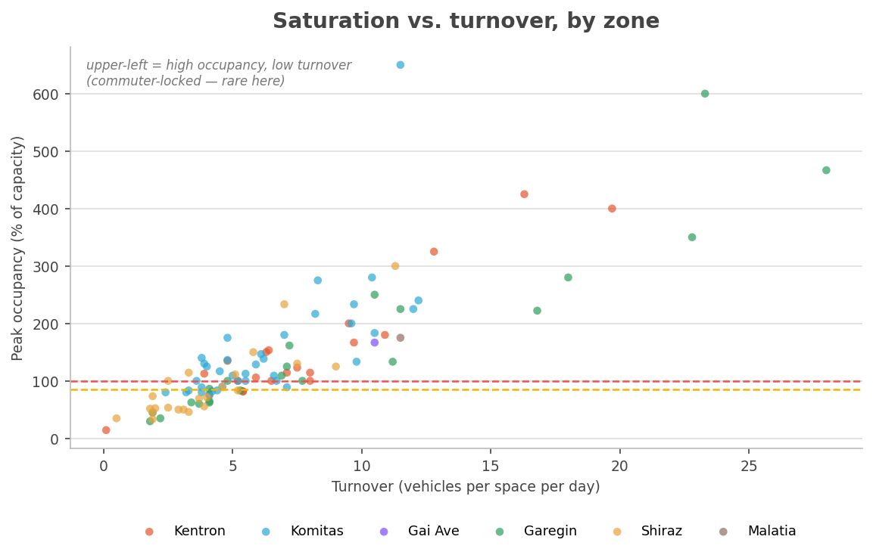
Each zone plotted by its turnover and its peak occupancy; colour denotes area.
What now — occupancy and turnover rise together — the busiest streets are also churning fastest, so the saturation is short-stay pressure, not all-day commuter storage. The lever is therefore pricing to keep a margin of spaces free, not blanket time-limits; reserve maximum-stay caps for the few high-occupancy, low-turnover outliers in the upper-left.
When each area peaks
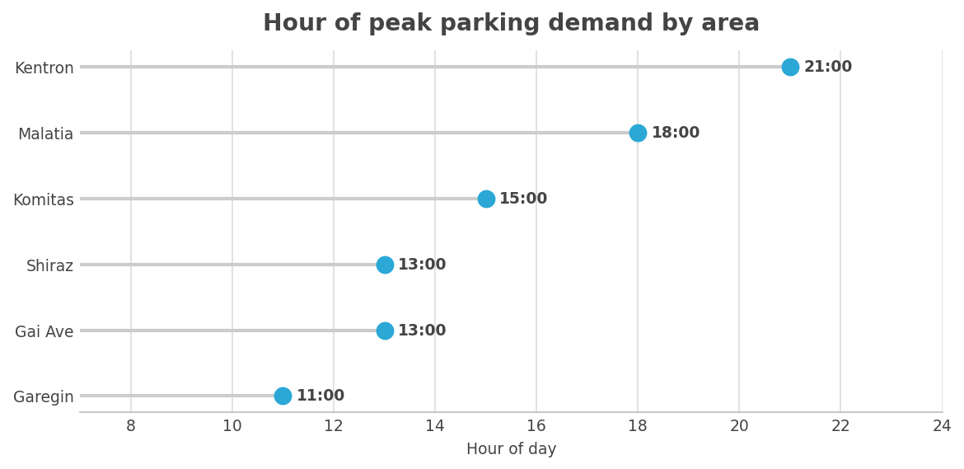
Clock hour at which each area reaches its highest parking demand.
What now — demand peaks at different times — late morning in the outer commercial areas, evening in the Kentron centre. Enforcement hours and loading-bay windows should follow each area's own clock; a single city-wide timetable would miss the pressure in half of them.
Day or night demand
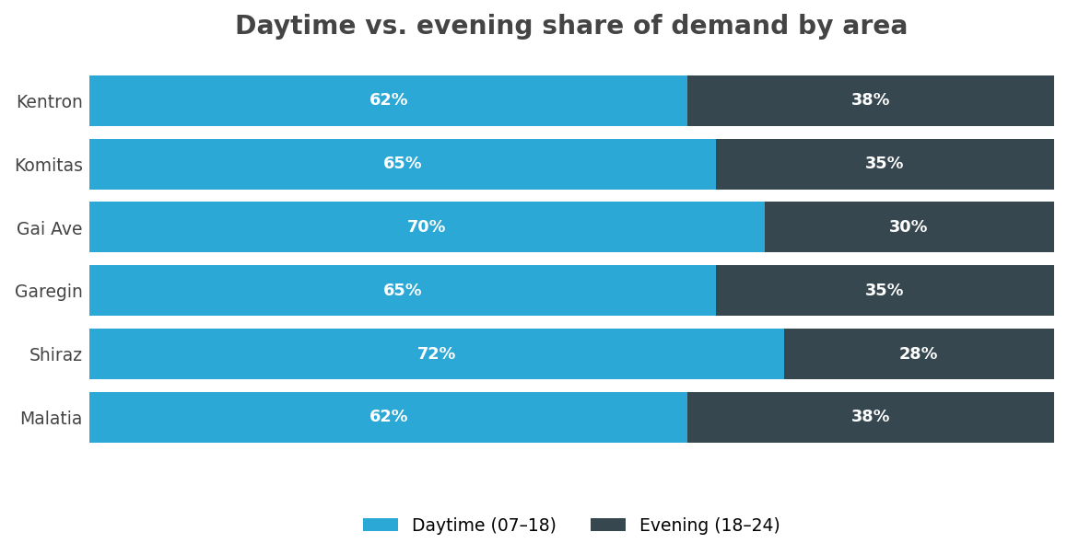
Share of each area's daily demand falling in daytime vs. evening hours.
What now — the evening-heavy areas (Kentron, Malatia) carry residential demand that this daytime survey only partly captures — protect them with resident provision. The day-heavy areas (Shiraz, Gai Avenue) are commercial and suit turnover pricing. Note the survey ends around midnight, so genuine overnight demand is understated, not absent.
How the kerb is laid out
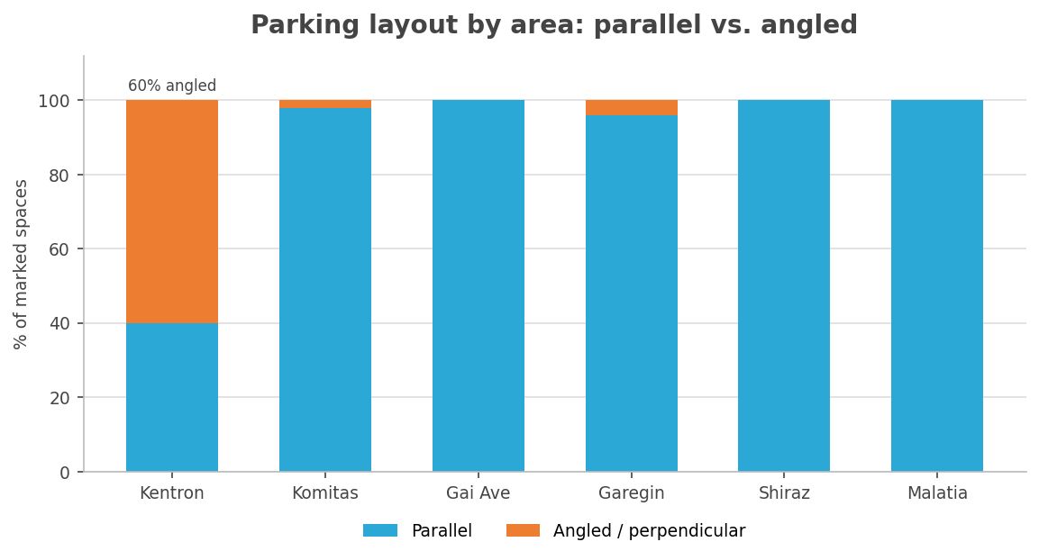
Share of marked spaces that are parallel vs. angled/perpendicular, by area.
What now — Kentron's kerb is roughly 60% angled parking, much of it informal — restructuring it into marked parallel bays restores order and pedestrian space even before any parking is removed. The other areas are already orderly parallel layouts and need no such intervention.
The base behind the percentages
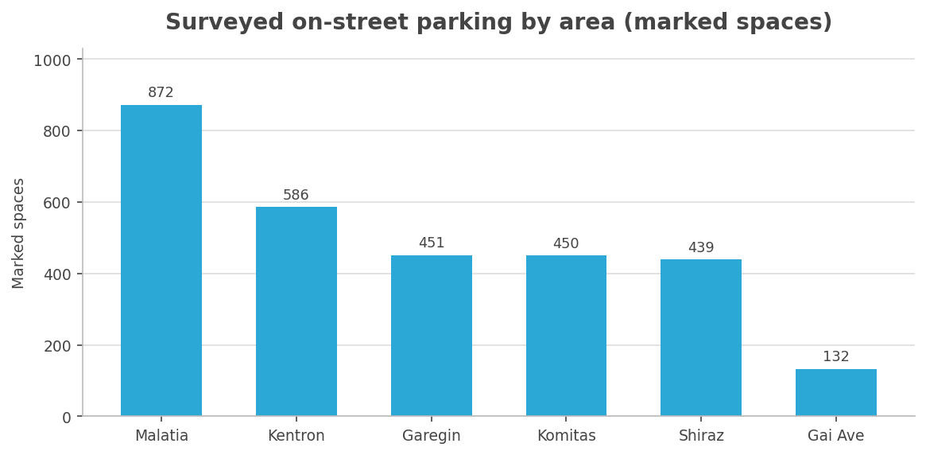
Total marked on-street spaces surveyed in each area.
What now — read the earlier percentages against this base — Malatia and Kentron hold the most spaces, so an equal percentage change there moves the most cars. Size mitigation budgets to the bars here, not to the number of areas.

Conclusions and recommendations
- Demand timing, not supply, is the problem. Network-wide the kerb is only 43% occupied across the working day but reaches 93% at the peak hour. More than half the kerb sits empty most of the day — the spaces exist, they are just all wanted at the same time and place. A genuine shortage would show up as a high daily average too; this does not. Capacity is therefore not the binding constraint city-wide — management of the peak is. (Kentron and Gai Avenue are the local exceptions, where capacity is genuinely tight.)
- Use pricing to manage peak demand. Across the network, kerb space is largely unpriced or under-priced relative to peak demand. Introducing or extending paid parking in the high-occupancy areas — set to keep a few spaces free even at the peak hour — is the most direct way to free up capacity, and the short-stay demand profile (most stays under two hours) means demand would respond.
- Manage the one local shortfall. The 1,643 spaces removed by the redesign displace 908 peak-hour cars, and nearby capacity can absorb them in every area except Gai Avenue. A targeted provision (additional yard capacity or phased removal) is recommended there.
- Lean on off-street capacity. Off-street yards do most of the heavy lifting in the displacement balance. Their capacity, pricing and signage should be confirmed and actively promoted so drivers actually use them.
All figures in this report are drawn directly from the field-survey dataset published in the interactive briefing (Step 9) and reflect the current model run.

Implications for the submitted deliverables (Outputs 8 and 10)
These field surveys were carried out in June 2026, after Output 8 (Traffic and Parking Surveys and Analysis Report, April 2026) and Output 10 (Parking Analysis Report, April 2026) had been submitted. Both deliverables were written on the explicit basis that no field occupancy or duration survey would be conducted — a position formally communicated to ADB and the PIU. The new evidence therefore requires a small number of targeted revisions to keep those deliverables internally consistent and defensible.
The recommendations below are deliberately limited to crucial changes — either because the new data now contradicts a statement we made, or because leaving the text unchanged would expose the work to avoidable criticism. Cosmetic or merely additive edits are not proposed, and each chapter ends with the points that should deliberately be left unchanged.
One scope note applies to both. The field surveys cover six selected high-impact areas (208 on-street segments, ~2,930 marked spaces) as a targeted demand overlay — not a repeat of the full corridor supply inventory (8,862 on-street spaces) documented in Output 8. The two are complementary; the field-survey totals must not be read as superseding, or contradicting, the inventory totals, and the retained/removed counts here reflect a per-area engineering judgement, not the full corridor removal figure (5,953).
For Output 8 — Traffic and Parking Surveys and Analysis Report
The single most significant issue is the chapter “Justification for Excluding Full-Scale Occupancy and Duration Surveys.” The remaining edits update the Displacement Assessment and the demand-data status now that real occupancy data exists.
1. Reframe the exclusion justification (critical — reputational)
The chapter states that a full-scale field occupancy survey was excluded and that “even highly detailed occupancy data would not materially influence design or policy recommendations,” citing a justification letter submitted to ADB and the PIU. A targeted field occupancy survey has since produced precisely the hourly occupancy, duration and turnover metrics the chapter said would not be collected. Left unchanged, the chapter is directly contradicted by the project's own subsequent work.
Recommended: keep the proportionality argument — a 34-km, 17-hour corridor-wide operation was disproportionate — but change the conclusion. The team did not abandon occupancy measurement; it scoped it down to a targeted survey of representative high-impact areas, conducted after submission to validate the displacement assumptions and to bridge the still-pending ANPR access. The absolute claim that occupancy data “would not materially influence design or policy recommendations” should be qualified: it holds for the design (parking is removed regardless of occupancy) but is no longer true for policy and mitigation, where the occupancy data has directly shaped the displacement and absorption assessment.
2. Quantify the Displacement Assessment
The Displacement Assessment currently argues — from European precedent only — that displaced demand is typically lower than the spaces removed, but puts no number on Yerevan because no occupancy data existed. The field survey now measures it: across the surveyed areas peak-hour parked demand on removed segments is ~908 cars against ~1,643 spaces removed — roughly 55%. Recommended: add this as local empirical confirmation of the “demand is lower than supply removed” principle. This strengthens the argument and is a defensibility asset (see Output 10, point 3), not mere padding.
3. Refine “Available Absorptive Capacity”
Output 8 presents absorptive capacity as a single large pool (7,479 off-street + 1,857 cross-street on-street) comfortably exceeding removal. The field survey confirms overall sufficiency but shows two things the current text omits: absorption is off-street-dominated — surviving and nearby on-street covers only ~43% of peak displaced demand city-wide and as little as ~14% in the Kentron core — and it is unevenly distributed, with one surveyed area (Gai Avenue) where even gross best-case nearby capacity (~89%) does not fully cover peak displaced demand. Recommended: keep the headline of sufficiency, but add these two qualifiers so the report does not imply that side-street conversion can absorb the centre.
4. Update “Occupancy and Demand Data: Current Status”
This section states that demand analysis is pending ANPR access and will follow as an addendum. That is now only half true — targeted field-based demand data exists. Recommended: revise to state that interim demand evidence has been obtained through the field survey, with ANPR retained as the future citywide, continuous source, and reposition the field survey as the interim addendum it effectively is.
Deliberately leave unchanged
- Supply-inventory totals: 16,341 / 8,862 / 5,953 — different scope from the field survey; the field figures do not supersede them.
- Regulation classification: the field survey under-records paid (red/blue) lines; Output 8's Zone A/B figures remain the reference for regulation.
For Output 10 — Parking Analysis Report
Output 10 carries the mitigation strategy, so this is where the new findings have the most consequence. Two of the edits below are reputational; the rest sharpen the mitigation logic with evidence the report previously lacked.
1. Reconcile the “field surveys were abandoned” statements (critical — reputational)
Output 10 states that “field surveys were abandoned” and that “detailed occupancy, duration, and turnover data are not required.” These must be reconciled with the completed survey using the same reframe recommended for Output 8. The section “Overview of Previous Field Survey Plans (Methodology),” which documents the abandoned 17-hour plan, should now note that a targeted version was subsequently executed and summarise its findings.
2. Recalibrate the high-sensitivity (Kentron) mitigation package (critical)
This is the most important substantive change. The “Mitigation Measure Packages by Sensitivity Zones” assigns the high-sensitivity core (Kentron — Nalbandyan, Amiryan, Tigran Mets) a curb-led package: extend paid zones, delivery spaces, visitor caps, resident permits. The field survey shows that in Kentron nearby on-street capacity absorbs only ~14% of peak displaced demand (Komitas 0%), and the centre already runs at 138% of capacity at peak — there is essentially no spare curb to convert. As written, the package promises absorption on streets the data shows are already full.
Recommended: for the high-sensitivity zone, lead with off-street measures — opening gated residential courtyards for daytime use, park-and-ride interception, and securing and structuring nearby off-street yards — and present the curb measures (paid-zone extension, visitor caps) as demand-management and turnover tools rather than as absorption capacity. Leaving the package curb-led would be contradicted by our own occupancy figures.
3. Turn “the corridor itself is the primary mitigation” into evidence
The central displacement argument — that the corridor reduces car demand so not every space needs replacing — currently rests on European precedent (Nantes, Metz, Rouen, etc.). Given the active court challenges demanding an empirical basis for parking decisions (a risk the report itself flags), the local finding that peak demand is only ~55% of removed supply is a material defensibility asset. Recommended: cite it where the “primary mitigation” logic is introduced.
4. Ground the pricing and turnover rationale in observed data
The pricing and visitor-cap measures currently rest on the theoretical 85% efficiency threshold and on ANPR data that is not yet available. The field survey shows central areas operating well above 85% at peak (Kentron 138%, Komitas 123%) and a demand profile dominated by short stays (~68% under two hours). Recommended: use these observed figures to support paid-zone expansion and visitor caps, and replace or supplement the “illustrative” ANPR figures (Figures 5–9), currently labelled hypothetical, with the actual field demand profile so the strategy no longer visibly rests on placeholder data.
5. Name the residual risk concretely
“Limitations and Residual Risks” is currently generic (some net reduction is expected and even desirable). Recommended: add the specific, evidenced case — Gai Avenue, where nearby capacity does not fully absorb peak displaced demand — as a worked example requiring targeted provision. A named, quantified residual risk reads as rigour; the same gap discovered after publication reads as an oversight.
Deliberately leave unchanged
- The residential overnight-storage hardship narrative: the survey ran daytime hours (≈07:00–24:00) and does not capture overnight residential demand, so it neither confirms nor refutes that concern and must not be used to downplay it.
- The resident-permit scheme: do not weaken it on the basis of the survey's low long-stay share — the observation window excludes the night, when that demand occurs.
- The off-street capacity headline: the survey supports, not contradicts, overall sufficiency — keep it.

